Kinzig Catchment: Urban vs Rural
Main Hypothesis

• Macroinvertebrate-mediated decomposition rates are expected to be higher in rural streams than in urban streams within the Kinzig catchment, and the rate of macroinvertebrate activity is expected to be proportional to the rate of overall decomposition.
Increased riparian vegetation in rural streams leads to higher input of allochthonous organic matter (Gessner et al., 1999), which enhances resource availability for decomposer communities. As a result, the density and activity of macroinvertebrates are likely elevated, so any introduced leaf material is expected to decompose faster in rural streams than in urban streams. In urban streams, limited organic matter supply supports fewer decomposers and less macroinvertebrate activity.
I will analyse whether rural streams, due to higher riparian vegetation and greater organic input, show overall faster leaf litter decomposition than urban streams, independent of other physical factors.

Secondary Expectations

• Microbial decomposition rates will be higher in rural streams than in urban streams.
Microbial decomposition rates, assessed as leaf mass loss in fine mesh bags, are expected to be higher in rural streams than in urban streams. Greater organic matter input and more persistent shading in rural streams are likely to promote abundance and activity of microbial decomposers, resulting in increased rates of microbial leaf breakdown compared to the reduced substrate availability typical of urban sites.
This hypothesis will isolate the microbial component of decomposition, predicting that microbial-driven breakdown is promoted by greater organic matter availability in rural streams.

• The difference between total decomposition and microbial decomposition, which represents macroinvertebrate decomposition, will be smaller in urban streams than in rural streams.
This hypothesis will check whether macroinvertebrates play a crucial role in breaking down leaves in rural streams, where there is more food and better habitat, and predicts that their role is smaller in urban streams, leading to a smaller difference between coarse and fine mesh bag decomposition.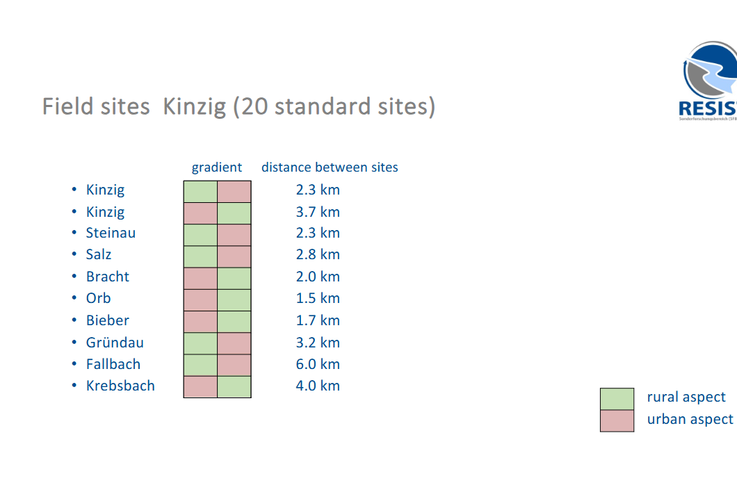
Figure 1: Paired urban and rural field sites along the Kinzig catchment used in the 2025 RESIST field study (source: RESIST Field project, 2025; https://nxcl.biologie.uni-due.de).

